1. **You have just taken out a 5​-year loan from a bank to buy an engagement ring. The ring costs ​$6,000. You plan to put down $ 2,000 and borrow ​$4,000. You will need to make annual payments of ​$1,250 at the end of each year. Show the timeline of the loan from your perspective. How would the timeline differ if you created it from the​ bank's perspective?**

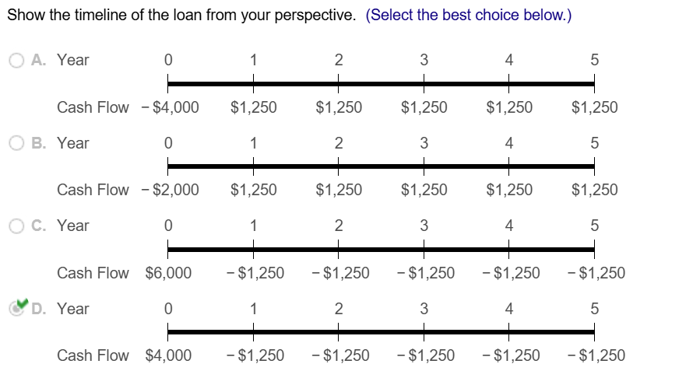

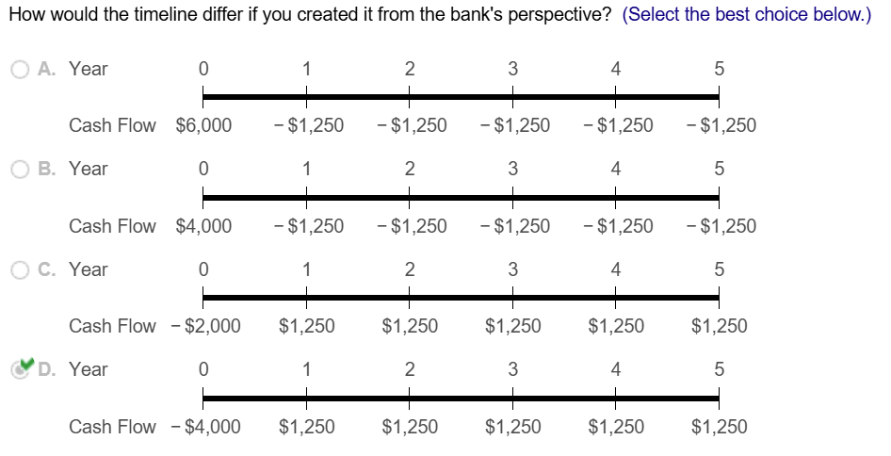

1. **What is the present value of ​$4,000 received**

**a. 14 years from today when the interest rate is 10 % per​ year?**

**b. 28 years from today when the interest rate is 20 % per​ year?**

**c. 7 years from today when the interest rate is 5 % per​ year?**

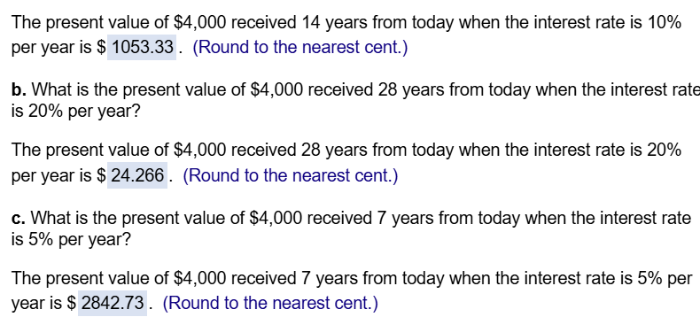

1. **Your brother has offered to give you either ​$45,000 today or ​$90,000 in 13 years. If the interest rate is 8 % per​ year, which option is​ preferable?**

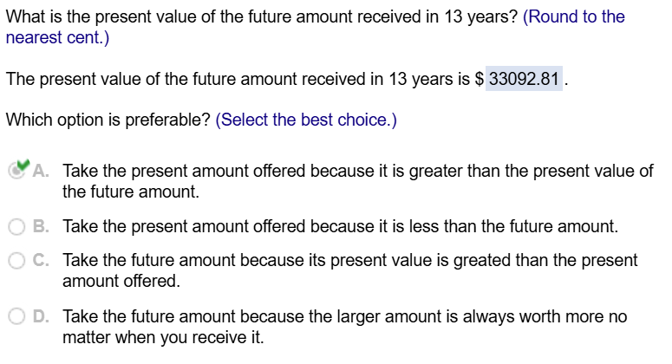

1. **Consider the following​ alternatives:**

**i.   ​$100 received in 1 year**

**ii.  ​$200 received in 5 years**

**iii. ​$300 received in 10 years**

**a. Rank the alternatives from most valuable to least valuable if the interest rate is 12 % per year.**

**b. What is your ranking if the interest rate is only 5 % per​ year?**

**c. What is your ranking if the interest rate is 19 % per​ year?**

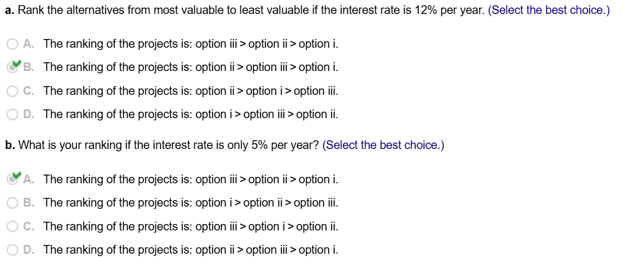

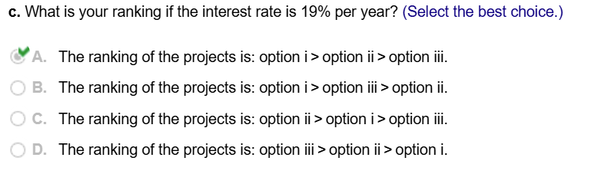

1. **Suppose you invest ​$1,000 in an account paying 6 % interest per year.**

**a. What is the balance in the account after 4 ​years? How much of this balance corresponds to​ "interest on​ interest"?**

**b. What is the balance in the account after 26 ​years? How much of this balance corresponds to​ "interest on​ interest"?**

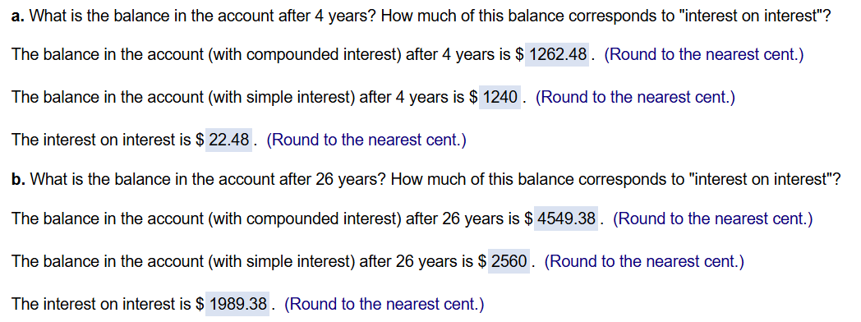

1. **Your daughter is currently 5 years old. You anticipate that she will be going to college in 13 years. You would like to have $ 120,000 in a savings account to fund her education at that time. If the account promises to pay a fixed interest rate of 11 % per​ year, how much money do you need to put into the account today to ensure that you will have $ 120,000 in 13 ​years?**



1. **Your grandfather put some money in an account for you on the day you were born. You are now 17 years old and are allowed to withdraw the money for the first time. The account currently has ​$5,642 in it and pays an interest rate of 8 %.**

**a. How much money would be in the account if you left the money there until your 30th ​birthday?**

**b. How much would be in your account if you left the money in the account until your 70th ​birthday?**

**c. How much money did your grandfather originally put in the​ account?**

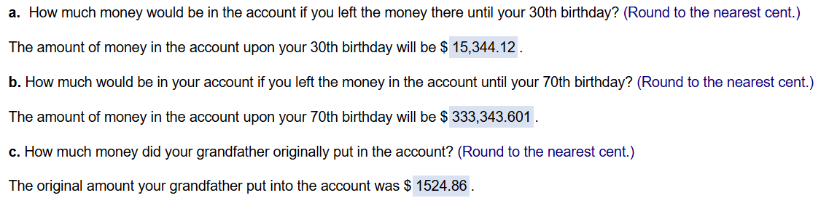

1. **You have a loan outstanding. It requires making 3 annual payments at the end of the next 3 years of ​$2,400 each. Your bank has offered to restructure the loan so that insted of making the 3 payments as originally​ agreed, you will make only one final payment at the end of the loan in 3 years. If the interest rate on the loan is 12 %​, what final payment will the bank require you to make so that it is indifferent between the two forms of​ payment?**



1. **What is the present value of ​$7,000 paid at the end of each of the next 80 years if the interest rate is 3 % per​ year?**

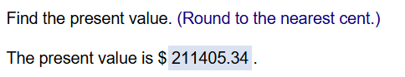

1. **A rich relative has bequeathed you a growing perpetuity. The first payment will occur in one year and will be ​$1,000. Each year after​ that, you will receive a payment on the anniversary of the last payment that is 4 % larger than the last payment. This pattern of payments will go on forever. If the interest rate is 13 % per​ year,**

**a. What is​ today's value of the​ bequest?**

**b. What is the value of the bequest immediately after the first payment is​ made?**

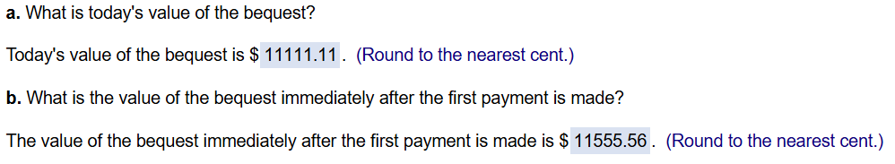

1. **Your oldest daughter is about to start kindergarten in a private school. Tuition is ​$15,000 per​ year, payable at the beginning of the school year. You expect to keep your daughter in private school through high school. You expect tuition to increase at a rate of 6 % per year over the 13 years of her schooling. If the interest rate is 6 % per​ year, how much would you need to have in the bank now to fund all 13 years of​ tuition?**



1. **Ten years​ ago, Diana Torres wrote what has become the leading Tort textbook. She has been receiving royalties based on revenues reported by the publisher. These revenues started at $ 1.3 million in the first​ year, and grew steadily by 5.8% per year. Her royalty rate is 18% of revenue.​ Recently, she hired an auditor who discovered that the publisher had been under reporting revenues. The book had actually earned 10% more in revenues than had been reported on her royalty statements.**

**a. Assuming the publisher pays an interest rate of 3.9% on missed​ payments, how much money does the publisher owe Diana​?**

**b. The publisher is short of​ cash, so instead of paying Diana what is​ owed, the publisher is offering to increase her royalty rate on future book sales. Assume the book will generate revenues for an additional 20 years and that the current revenue growth will continue. If Diana would otherwise put the money into a bank account paying interest of 5.3%​, what royalty rate would make her indifferent between accepting an increase in the future royalty rate and receiving the cash owed today.**

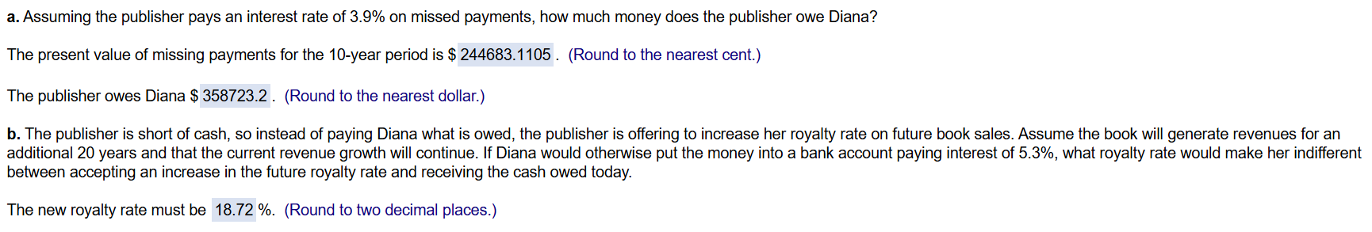

1. **Suppose you currently have ​$4,500 in your savings​ account, and your bank pays interest at a rate of 0.47 % per month. If you make no further deposits or​ withdrawals, how much will you have in the account in 4 ​years?**



1. **You have just made an offer on a new home and are seeking a mortgage. You need to borrow ​$581,000.**

**a. The bank offers a 30​-year mortgage with fixed monthly payments and an interest rate of 0.47 % per month. What is the amount of your monthly payment if you take this​ loan?**

**b. ​Alternatively, you can get a 10​-year mortgage with fixed monthly payments and an interest rate of 0.41 % per month. How much would your monthly payments be if you take this loan​ instead?**

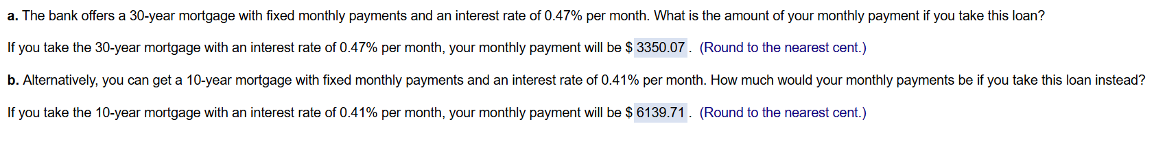

1. **You are 37 years​ old, and decide to save ​$7,500 each year​ (with the first deposit one year from​ now), in an account paying 9 % interest per year. You will make your last deposit 28 years from now when you retire at age 65. During​ retirement, you plan to withdraw funds from the account at the end of each year​ (so your first withdrawal is at age 66​). What constant amount will you be able to withdraw each year if you want the funds to last until you are age 95​?**

